Investigations on Odor Elimination with Hydrochloric Acid and Ferric Chloride Application to Biosolids Matrix
Pre-Proposal Description of Project
for Qualifying Exam Preparation

Phillip Bennington, P.E.
Ph.D. Student
Environmental Sciences and Engineering
Institute for a Sustainable Environment
Clarkson University

February 28, 2025

Abstract
Nuisance odor emissions have accompanied a wide range of public, industrial and agricultural wastewater treatment facilities. These facilities consist of a liquid and solids treatment process that specifically reduces the wastewater pollution to acceptable levels prior to release into the environment. Solids treatment processes may include dewatering processes, storage, transport and land applications of anaerobically digested sludges. The nuisance odors emitted from solids treatment processes have resulted in complaints from employees and the public, requiring mitigation of such odors.
This study investigates the mitigation of ammonia (NH₃) and hydrogen sulfide (H₂S) released from anaerobic digestion solids via the application of ferric chloride (FeCl₃) and hydrochloric acid (HCl). NH₃ and H₂S are prominent odorous compounds released in anaerobic digestion solids treatment processes. The test bed for the study is the City of Dayton Water Reclamation Facility located in Dayton, Ohio. To minimize the release of NH₃ and H₂S concentrations in air, ferric chloride and hydrochloric acid have been applied at this facility and have been effective both at reducing odorous emissions and preventing struvite formation. However, a comprehensive understanding of the chemical mechanisms and optimization of this odor treatment system have not been developed.
In this work, the chemical mechanisms responsible for the NH₃ and H₂S emission reductions are described. A bench scale study using anaerobic digestion solids from the City of Dayton Water Reclamation Facility and various levels of FeCl₃ and HCl application will be conducted to identify the optimum chemical applications for the mitigation of NH₃ and H₂S odors to be used for the full-scale operation. A full-scale study will be conducted for which continuous NH₃ and H₂S data from the full-scale operation will be analyzed to validate the optimization and assess the maintenance and sustainability of the system. Best practices necessary to minimize the formation of unwanted precipitates such as struvite, vivianite, and calcium carbonate within the solids handling areas of the solids treatment processes will also be developed.

Contents
1.0 Introduction 3
1.1 History of Wastewater Treatment Odor Control 3
1.2 Common Odorous Compounds at Wastewater Treatment Plants 3
2.0 Current Technologies to Reduce Odor Emissions 5
2.1 Description of Odor Control Technologies 5
2.3 Chemical Precipitation in Biosolids Processing 8
2.4 Knowledge Gap 9
2.3 Proposed Ph.D. Thesis Work 10
3.0 Previous Odor Control Evaluations at Dayton WWTP 11
4.0 Current Odor Control Practices at Dayton WWTP 15
5.0 Benefits of this Research 22
6.0 Methods Proposed for Ph.D. Dissertation Work 23
6.1 Tasks, and Timeline for Proposed Project 27
7.0 References 28

Introduction

1.1 History of Wastewater Treatment Odor Control
Throughout the world, societies have constructed human waste handling and treatment facilities away from populated areas. As populations increase and urban sprawl grows, nuisance odors for these communities increase. These nuisance odors originate from processes such as landfills, agricultural practices, livestock and dairy farms, wastewater treatment plants (WWTPs), and industrial pollution. The problem of nuisance odors are throughout the world (Brancher et al. 2017), have resulted in an increase of vehement protests (Hsu et al. 2019). Failure to address odor emissions can result in complaints, shutdowns, expensive retrofits, and non-acceptance of the finished product. Every operation should keep a systematic record of odor complaints and provide odor control processes to mitigate the problem (Hsu et al. 2019).
Odor emissions and associated complaints are common for anaerobically digested biosolids processes (HWS Consulting Group, October 2017). Historically, the handling of biosolids at the facility and while transporting the biosolids on roadways has generated nuisance odors that resulted in complaints from employees at the facility and from neighbors that are near the treatment plants and application sites (USEPA, 2000). While there are many technologies applied for odor control, odor problems persist and there is a need to improve odor control strategies for anaerobically digested biosolids processing.

1.2 Common Odorous Compounds at Wastewater Treatment Plants
Table 1.1 below lists some of the most significant odorous compounds that are produced at WWTPs. Ammonia (NH₃) and hydrogen sulfide (H₂S) are the most common odorous compounds that are experienced and may result in odor complaints and unhealthy exposures (Ren et al. 2019).

Table 1.1 Key chemical emissions from WWTPs and the ranges of odor thresholds (adapted from Ren et.al 2019)

Odorous Compounds | Odor  Description | Chemical  Formula | Odor  Threshold  (ppb) | Health  Guidelines  (TLV)
Ammonia | Sharp, pungent | NH3 | 130–15300 | 25 ppm
Butanone | Sweet, minty, green apple | CH3C(O)CH2CH3 | 270 | 75 ppm
Dimethyl sulfide | Decayed vegetables | (CH3)2S | 0.12–0.4 | N/A
Hydrogen sulfide | Rotten eggs | H2S | 0.5 | 1.0 ppm
Methyl mercaptan | Decayed cabbage, garlic | CH4S | 0.0014–18 | 0.5 ppm
Sulfur dioxide | Pungent, acidic | SO2 | 9 | 0.25 ppm

Biosolids may emit a distinctive odor depending on the treatment process and treatment methods used. The odorous compounds generated and detected most often are ammonia, amines, and reduced sulfur-containing compounds. However, the presence of biosolids odors does not mean that the biosolids pose harm to human health and the environment (USEPA, 2000). Human exposure and risk can be assessed based on the known toxicity data for the individual compounds and chemical interactions.
Dewatered biosolids that have been placed in storage areas, loaded into trucks, transported to farm sites, and spread on farmland have a continuous release of volatilized NH₃ and H₂S gas. The rate of NH₃ volatilization increases with increased pH, moisture content, wind speed, NH₃ concentration, and temperature (Reddy et al., 1979). As the pH raises the NH₃ to NH₄ ratio increases, resulting in increased volatilization rates (DeLaune et al. 2004). The loss of nitrogen, an important nutrient, via NH₃ volatilization from the solids applied to agricultural lands is an additional negative effect of this process (DeLaune et al. 2004).

2.0 Current Technologies to Reduce Odor Emissions
There are many odor control technologies that are used to reduce odors from anaerobically digested sludge. These odor control technologies include adsorption, chemical scrubbing, biofiltration, bio-trickling, bio-scrubbing, activated sludge diffusion and various hybrid technologies. Each technology has pros and cons in its application to reduce odorous air pollutants, which will be reviewed in this chapter. Treatment plant operators strive to achieve safe, environmentally friendly technologies which are cost effective.

2.1 Description of Odor Control Technologies
Physical and/or chemical odor control technologies typically consist of chemical scrubbing and adsorption. Chemical scrubbing (Figure 2.1) involves circulating water over media with a chemical. The odorous air enters the bottom of the scrubber, impacts the media, and exists through the top of the scrubber. The odorous air is chemically treated while in contact with the media and coated with sodium hypochlorite. This reaction causes the pH on the aqueous solutions that cover the media to suppress, and sodium hydroxide must be added to elevate the pH back into the basic range for the reaction to be optimum. Odorous air can also be treated using a media that adsorbs the odorous molecules onto the media (Figure 2.1).
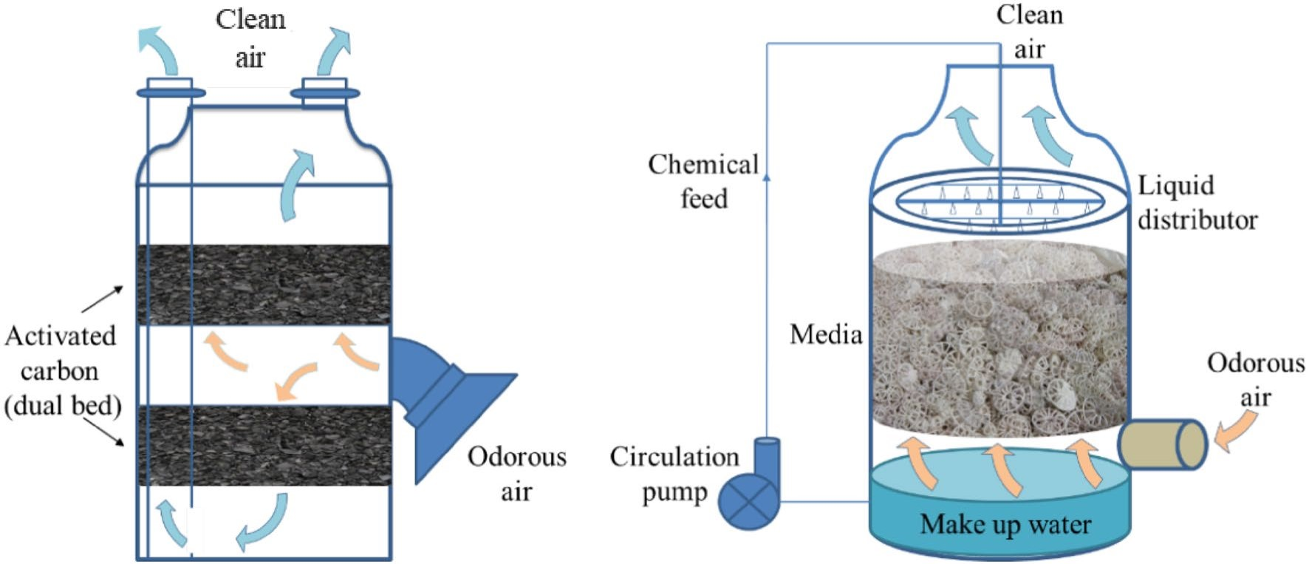

Adsorption Chemical Scrubbing

Figure 2.1 Physical and Chemical Scrubbing. (Adapted from Ren et al., 2019)

Both chemical scrubbing and adsorption techniques require one or more towers to house the media, ductwork, and blower to collect the odorous air from the generating sources to the tower for treatment. Installation for both the chemical scrubbing and adsorption processes requires a high capital construction cost initially, along with daily labor-intensive monitoring requirements to assure optimum daily performance. In addition, the activated carbon process requires careful installation and routine replacement with reactivation, if possible, of the activated carbon. All the requirements for the successful operation of these processes can be cost prohibitive in many cases (Ren et al., 2019).
There are four types of biotechnological treatment reactors used to treat odorous air at WWTPs: biofilters (BF), bio trickling filters (BTF), bio scrubbers (BS) and activated sludge diffusion reactors (ASD), see Figure 2.2 below. The BF is the most widely used biotechnology at WWTPs today (see Figure 2.2 (a)). The biofilter requires minimal maintenance, and combinations of different media can be used. Also, the media can last up to five years before media replacement is necessary. However, only three out of 16 different media combinations have been shown to reduce ammonia to some degree (Ren et al., 2019). The media combinations that can reduce ammonia emissions are wood chips, compost, and wood bark, but even these media have poor ammonia reduction efficiencies (Ren et al., 2019).
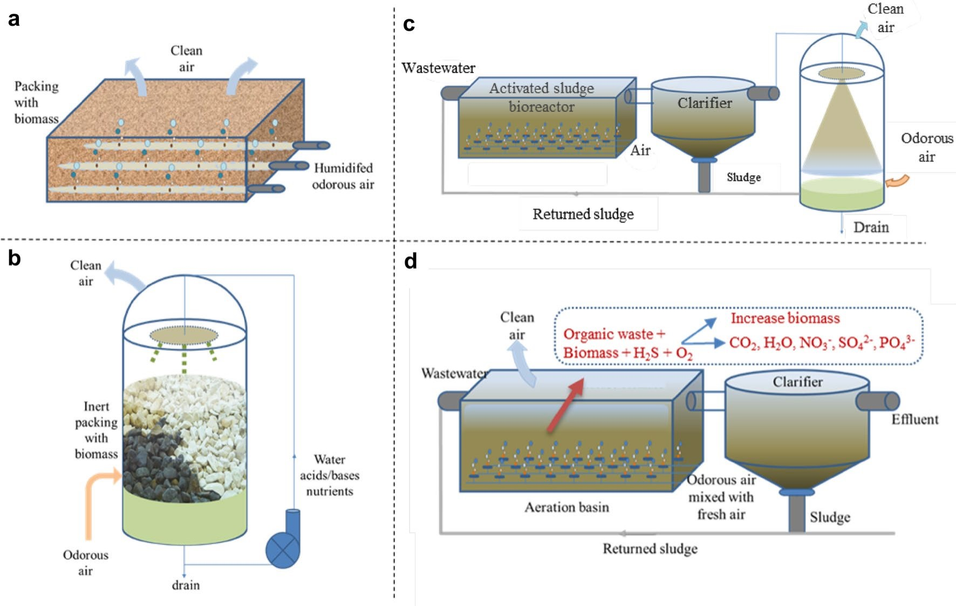
Figure 2.2 a) Open Biofilter, b) Biotrickling Filter, c) Bioscrubbers, d) Activation Sludge Diffusion (Adapted from Ren et al., 2019).

Advanced oxidation processes (AOP) were first applied to water treatment in the 1980s and then moved into the wastewater field (Deng and Zhao, 2015). AOPs are mentioned here to demonstrate extensive research in AOPs, their combinations, and applications which could be used in odor control. AOPs were developed for the destruction of organic and inorganic contaminants in water and wastewater (Deng and Zhao, 2015). These AOPs include, but are not limited to (Deng and Zhao, 2015):
- Hydroxyl Radical-Based
- Ozone-Based
- UV-Based
- Fenton-Related
- Ultrasound irradiation
- Electronic beam irradiation
- Alternate compression and rarefaction cycles
- Electronic beam irradiation (splitting water)
- Sulfate Radicals
There is extensive research using AOPs in wastewater treatment. However, available literature for the application of AOPs for ammonia mitigation are limited to leachate using sulfate radical (SO4·−) based advanced oxidation process (SR-AOP) (Deng and Ezyske, 2011). To my knowledge, there has been no mitigation of NH₃ or odors from biosolids processing using SR-AOP or other AOPs.
NH₃ is a nutrient that is beneficial for farmland applications. Thus, preservation of the ammonia prior to land application is desired for beneficial reuse.
The chemical reaction of NH₃ and HCl is (Tao, 1999):
NH₃ +HCl NH₄Cl.

2.3 Chemical Precipitation in Biosolids Processing
Chemical precipitation may occur in dewatering of anaerobically digested biosolids resulting in the formation of unwanted precipitates such as struvite, vivianite, and calcium carbonate. In particular, struvite, which is magnesium ammonium phosphate, may be generated because of the changing characteristics of the biosolids during the process. The struvite formation is from the general equation (Wu, Bishop, and Keener, 2005):
Mg²⁺ +NH₄⁺+PO₄³⁻ +6H₂O MgNH₄PO₄. 6H₂O
Struvite precipitation occurs when the combined concentrations of Mg²⁺, NH₄⁺ and PO₄³⁻ exceed the struvite solubility product. Struvite solubility is a function of the pH (Marti et al., 2008).
The addition of FeCl₃ to the biosolids for the prevention of H₂S emissions from the transferred biosolids prior to dewatering yields:
2Fe3⁺ + S2⁻ 2Fe2⁺ + S⁰
2Fe³⁺ +3HS⁻ Fe²S³ + 3H⁺ (Erdirencelebi and Kucukhemek 2018)

2.4 Knowledge Gap
The odor reducing processes presented in Section 2.1 require a high capital construction initial cost along with daily labor-intensive monitoring requirements to assure optimum performance. None of the odor control technologies have demonstrated high efficiencies to successfully reduce biosolids odors. In particular, there is need for improved processes for ammonia removal. Even with the limited treatment success of ammonia removals with the BF, there are significant problems with ammonia removal efficiencies using BFs during cold weather winter months in some regions (HWS Consulting Group, 2017).
The most effective treatment in removing ammonia may be through safe chemical applications directly at the odorous sources. Chemical applications prevent high costs associated with construction and installation of large air ducts, blowers, media replacement, chemicals applied to media and labor-intensive monitoring.
There is a need for ammonia emissions from solids processing to be addressed. Current investigations on the effects of odors traveling offsite into neighborhoods confirmed that ammonia odors can travel off-site into surrounding areas (Bennington, 2021). For the City of Dayton Water Reclamation Facility, the test bed for the proposed work, these off-site areas included the surrounding neighborhoods, recreational areas such as bikeways and the Great Miami River. High NH₃ concentrations in these areas were previously noted in reports by Webster Environmental Associates, Inc., (2008, 2015) and HWS Consulting Group (2017).

2.3 Proposed Ph.D. Thesis Work
The focus of this research is to describe, evaluate, and optimize the mitigation of odors starting at the surge tank where anaerobically digested sludge is transferred and then continuing through the entire dewatering process to land application of biosolids on farmland. The overall goal of this thesis is to develop the knowledge to enable full-scale implementation of anaerobically digested biosolids handling which mitigate ammonia, and hydrogen sulfide along with minimizing struvite formation using an odor control system. The project objectives are to:
- Describe the chemical mechanisms that result in the reductions of ammonia and hydrogen sulfide via chemical application of hydrochloric acid and ferric chloride to anaerobically digested biosolids during wastewater treatment dewatering process.
- Optimize the application of hydrochloric acid and ferric chloride to anaerobically digested biosolids via a bench scale study to minimize ammonia and hydrogen sulfide emissions.
- Optimize the application of hydrochloric acid and ferric chloride to anaerobically digested biosolids via a bench scale study to minimize struvite formation during the biosolids dewatering process.
- Apply the result from objectives 1-3 to assess the impact of hydrochloric acid and ferric chloride application to anaerobically digested biosolids in a full-scale dewatering process, with respect to the emission of ammonia and hydrogen sulfide gases, as well as the reduction of struvite formation.
The City of Dayton Water Reclamation Facility located in Dayton, Ohio will be used as a test bed for this research.

3.0 Previous Odor Control Evaluations at Dayton WWTP

The City of Dayton, Division of Water Reclamation Treatment plant is designed to treat 72 million gallons per day (MGD), serving 400,000 customers, and sits on more than a 100-acre footprint. The treatment plant consists of preliminary, primary, secondary, nitrification, tertiary anthracite filters, chlorination and dechlorination processes. Sludge from two (North and South) primary raw sludge clarifiers, waste activated sludge (WAS), and secondary trickling filters comprise the feed sludge composition pumped to 6 anaerobic digesters. The three East digesters are 85 ft in diameter and 30 ft deep and the West digesters are 80 ft in diameter and 30 ft deep.
The anaerobic digesters transfer the digested sludge to a surge tank located at the dewatering facility. The transferred volumes of sludge differ daily and are based on the elevations within each anaerobic digester. A cationic polymer is added at two points just prior to entry into the two (2) gravity belt thickeners and again just prior to entry into the two (2) centrifuges, see Figure 4.1, below. The dewatered biosolids are then transported onsite to a 1-acre covered storage building. The biosolids are then weighed and transported to a certified land application farm site. The State of Ohio has a delegation over enforcing federal 503 regulations. Therefore, the biosolids must meet state requirements for class B biosolids land application. The division has a goal to minimize odors throughout the treatment plant processes which include the dewatering facility, storage area, and transportation of biosolids to the certified land application sites.
The city hired two independent odor consultants in 2010 and again in 2017 to provide recommendations for odor control throughout the facility. Both consultants determined that their focus at the biosolids area of the plant would be to evaluate H₂S, organic total reduced sulfur (TRS), volatile organic compounds (VOC’s), ammonia, amine, organic acids, alcohols, and aldehydes (see Tables 3.1 and 3.2).
Measurements from the HWS Consulting Group (2017) found the odors at the belt press were determined to be 1 to 7 ppmv for ammonia and total amines. The biosolids conveyor area was found to have 0.5 to 6 ppmv for ammonia and total amines, respectively and H₂S gas measured 0.13 ppm (HWS Consulting Group, 2017). When factoring in the odor emission rates, the dewatering building had the highest observable emission rates (OER) followed by the sludge surge tank and the biosolids storage building. All three sources were significant, and all could be contributing to off-site odor detection (Webster Environmental Associates, Inc., 2008).
Table 3.2 shows that five reduced sulfur compounds were found in the air. The concentrations of these compounds were not extremely high, but were above the human odor detection threshold, and they could be detected off-site (Webster Environmental Associates, Inc., 2008). On-site sampling in the biosolids areas was conducted and six samples were collected for odor panel analysis and six samples were collected for reduced sulfur compound (RSC) analyses. The odor panel analyses provided the detection thresholds (DT) and recognition thresholds (RT) for each air sample. Perimeter odor surveys were performed to determine the ambient detection thresholds at the biosolids dewatering area. A detection threshold was measured using a Nasal Ranger Field Olfactometer, a portable odor detection device and additional data including wind speed, wind direction, hydrogen sulfide, and odor character (Webster Environmental Associates, Inc., 2008). Additional testing was performed by Webster Environmental Associates, Inc. in 2014 that included the biosolids dewatering areas. The custom-built biofilter had the lowest total annual cost for both systems and was the recommended system for this project (Webster Environmental Associates, Inc., 2008). Fortunately, the Dayton WRF biosolids processes are much less odorous than most previously sampled plants for both H₂S gas and ammonia concentrations that typically exceed 20 ppm and 90 ppm respectively (HWS Consulting Group, 2017). The biggest disadvantages of the biofilter option were the large footprint requirements and the lack of the vendor guarantee on biofilter performance or materials (Webster Environmental Associates, Inc., 2008). Another drawback to the biofilter technology was that ammonia can be toxic to biofilter bacteria and accelerate media degradation (HWS Consulting Group, 2017).
Table 3.1: Dewatering Building Odor Data (HWS Consulting Group, October 2017).

Process | NH3  (ppm) | Amines (ppm) | H₂S  (ppm) | Odor (DT) | Notes
West Belt Press - Near  Sludge | 0.5 | 6 | 0.04 |  | High airflow from cross ventilation between rollup door and room door help dilute these odors.
West Belt Press Drain Area |  |  | 0.09
East Belt Press - Near  sludge | 1 | 7 | 0.15
Conveyor next to biosolids | 0.5 | 6 | 0.13
Trucks | 1 | 8 | <0.25
Centrate Discharge Well | 7 | 24 | 0.65
Room Middle (foot  traffic area) | 0.5 | 7 | 0.03,  0.06¹ | 60 | Recognizable but not excessively  higher than 60 D/T
50' Downwind of Fans |  |  |  | 15 | Detected

1 - Measurement taken with roll-up door and room doors closed which caused a slight increase in H₂S gas.

Table 3.2 (Webster Environmental Associates, Inc., 2008).
 | RSC Testing ⁽¹⁾
 | H₂S | COS | MM | DMS | CDS | DMDS | DMTS
Location | (ppb) | (ppb) | (ppb) | (ppb) | (ppb) | (ppb) | (ppb)
Sludge Surge Tank (7/16/13) | 95 | 7.3 | <3 | <3 | <3 | <3 | <1
Dewatering Building Exhaust (7/16/13) | 20 | 20 | <3 | <3 | <3 | <3 | <1
Biosolids Storage Building Exhaust (7/16/13) | 10 | 5.3 | <3 | 10.0 | <3 | 1.7 | <1
Notes:
- Laboratory Reduced Sulfur Compound (RSC) results are reported in parts-per-billion (ppb). < symbol indicates concentration was less than the method detection limit for that compound.
RSC Abbr. (odor threshold, ppb): H₂S = hydrogen sulfide (0.5), COS = carbonyl sulfide (100), MM = methyl mercaptan (0.5), DMS = dimethyl sulfide (0.1), CDS = carbon disulfide (25), DMDS = dimethyl disulfide (0.1), DMTS = dimethyl trisulfide (0.1)

Five different 40,000 CFM odor control systems were submitted for review. The capital costs ranged from $726,800 to $1,197,150 in 2008 dollars (Webster Environmental Associates, Inc., 2008). Our calculations showed that in today’s asset costs this level could be as high as ($1,197,150. * 1.05¹⁶= $2,613,228.). The annual operating costs ranged from $113,829 to $200,205 dollars. However, HWS Consulting Group recommended a solution of six options ranging from a total present worth calculated for an 8-year cost @ 7%, 8 year that ranged from $3,975,353 to $5,443,347. Our calculations showed that in today’s asset costs this level could be as high as ($3,975,353. * 1.05⁷= $5,593,721.). The annual operating costs ranged from $46,767 to $70,201 dollars.
In 2020, the division wanted to reevaluate the biosolids areas. Based on the historical findings of these previous analytical results from both consultants, the division started an internally investigate odor control specifically directed at ammonia, and hydrogen sulfide.

4.0 Current Odor Control Practices at Dayton WWTP
Currently hydrochloric acid at 32% solution is applied at the surge tank continuously at a rate of 6,230 lbs./day and ferric chloride at 38% solution is fed at 583 lbs./day. A continuous Acrulog™ (Clontarf, Australia) NH₃ Gas Monitor (PPM) logger monitor is capable of detecting ammonia levels between 0-100 ppm and has a precision of 2 ppm. The continuous Acrulog™ H₂S Gas Monitor has a range from 0-2000 ppm with a precision of 5 ppm.

TABLE 4.1: Sample locations, measurements, equipment and type.
Sample Location | Analysis of Measurements | Sample Equipment | Sample Type
Surge Tank | Ammonia | Acrulog Logger | Air/Continuous
Surge Tank | H2S | Acrulog Logger | Air/Continuous
Filtrate/Centrate/Biosolids | pH | Lab pH Meter | Liquid/Grab
Filtrate/Centrate/Biosolids | Alkalinity | Lab pH Meter | Liquid/Grab
Biosolids | H2S | Sensodyne / Air Tubes | Air/Continuous
Biosolids | Ammonia | Sensodyne / Air Tubes | Solid/Air/Composite
Biosolids | Struvite | Visual | Solid/Composite

Sample analysis described in Table 4.1 will be continued for the full-scale application indefinitely to provide data for confirming the optimization and effectiveness of the system. In addition, identification of struvite and other deposit formations will be completed using semi-quantitative elemental analysis by Energy Dispersive Spectroscopy (EDS).
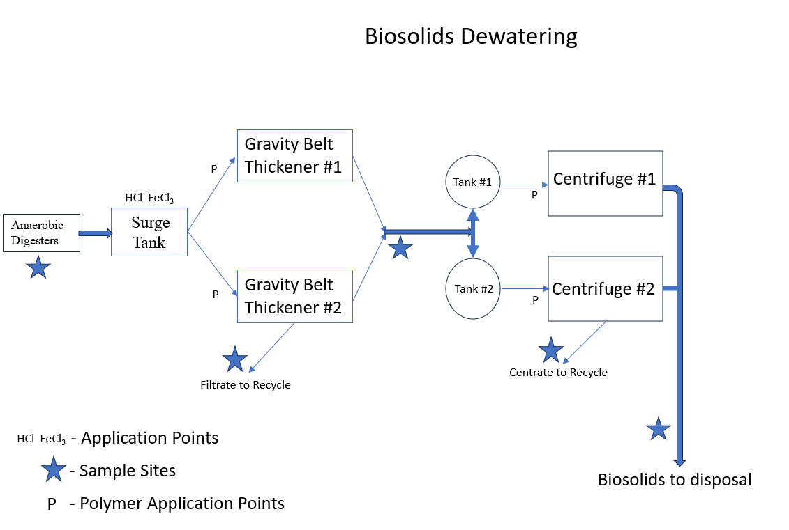
Figure 4.1: Dewatering building layout, sample sites and chemical application points

Figure 4.1 shows the flow through the dewatering building starting at the left of the figure. Both HCL and FeCl₃ are added to the surge tank. The digested sludge is pumped to the gravity belt thickener (GBT). Polymer is added just prior to the GBT. From the GBT the thickened biosolids to pumped to holding tanks just prior to the centrifuges. Prior to the centrifuges, polymer is added a second time in the process stream. After the centrifuges further thicken the biosolids a conveyor moves the biosolids to dumpster trucks that transport the biosolids to a storage building. Sample sites where samples are collected are indicated with a star on Figure 4.1.
Figures 4.2 and 4.3 indicate how the various parameter concentrations change during the week. For example, when the HCl is shutoff for one day in preparation for receiving a new HCl shipment on each Thursday, the NH₃ increases. The HCl feed rate is set-up to empty one-day before delivery on each Thursday. When the HCL is turned off, the NH₃ can reach 58 mg/m³ which can be seen in Figure 4.2. Digested sludge is transferred to the surge tank from each of six (6) digesters each day. All the existing sampling site analysis has continued from the small-scale pilot through the full-scale pilot study at the same sample sites which include the anaerobically digested sludge, thickened sludge from a gravity belt thickener, filtrate, centrifuges, centrate and the dewatered area.
Table 4.2 Analysis of dewatering process from April 2024.
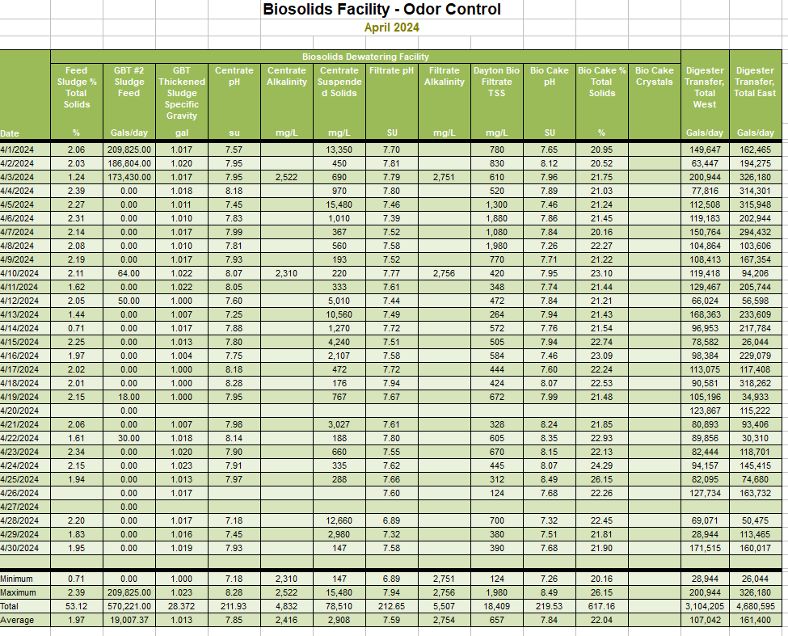
Laboratory analysis is currently ongoing on all five (5) sample sites found in Figure 4.1. The analysis continues to include pH, alkalinity, ammonia (liquid and gas), hydrogen sulfide (gas), presence of struvite in the biosolids and recently week-long continuous monitoring of both ammonia and hydrogen sulfide. Both HCl acid and FeCl₃ application volumes, weights (lbs./day), and dosages (mg/L) are determined based on daily sludge volumes transferred into the surge tank.
Starting in January 2024 we started to continuously measure for both NH₃ ammonia and H₂S hydrogen sulfide gas in the surge tank for sampling periods lasting a month.

Figure 4.3 Time series plot of NH3 concentration over one-month continuous monitoring.
Figure 4.4 shows a time series plot of the airborne concentration of ammonia and amount of HCl dosage (mg/L) added to the tank liquid during one week. The costs of the chemical addition have been calculated to be $510/day at the bulk chemical rate. Due to the secondary effects of adding HCl to the biosolids, the % total solids increased from 20% to 23% total solids. The city will save a total of $625/day in reduced hauling of excess water. This difference indicates that the city will have net savings in costs while applying HCl.
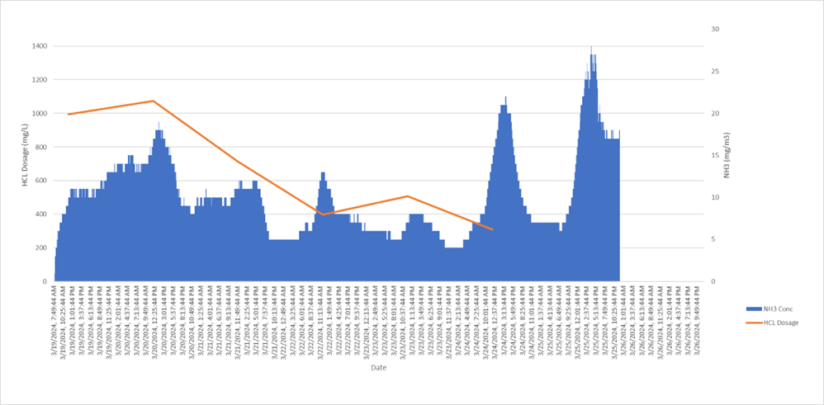
Figure 4.4 Ammonia concentration and applied dosage of HCl addition over one week.

Through the investigation of the anaerobic digester system, a significant amount of vivianite (Fe₃(PO₄)₂.8H₂O) was formed on the feed lines leading to the anaerobic digesters. The vivianite was identified using semi-quantitative elemental analysis by Energy Dispersive Spectroscopy (EDS). A savings of hauling costs was identified by the dewatered biosolids total percent solids increase resulted in a savings of hauling cost (Wu, Bishop, and Keener, 2005).

Struvite (MgNH₄PO₄·6H₂O) precipitation and subsequent accumulation within sludge processing has been identified at the biosolids dewatering facility. Struvite reflective crystals were identification in biosolids samples. Additional evaluations were conducted by looking at biosolids samples through a microscopic to see if we could possibly identify struvite crystal formations.

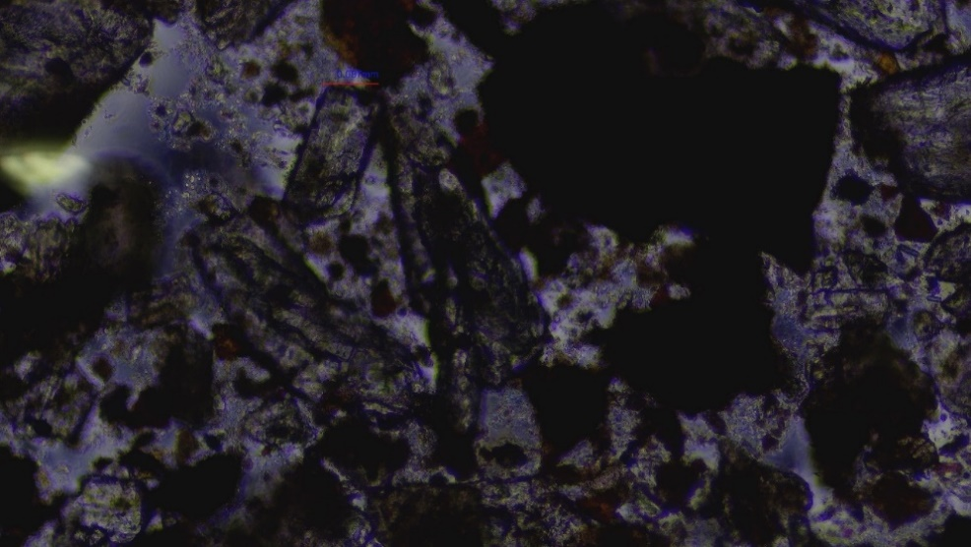
Figure 4.5 Struvite crystals identified by Infrared Spectroscopy (FTIR) and Semi-quantitative elemental analysis by Energy Dispersive Spectroscopy (EDS).

The morphology of struvite crystals was reviewed in the laboratory using an Accu-Scope, EXC-350 Series, microscope to identify possible formation of early struvite crystal formation as can be seen in Figure 4.5. The crystal formations were compared with known existing crystals previously identified. At a power of X100 and with proper lighting, we were able to compare similar crystal structure formations within the known struvite sample seen in Figure 4.5 and then compared within the biosolids sample seen in Figure 4.6. Only one struvite crystal was identified with the morphology configuration seen in Figure 4.6, where the red line is located. Only a small amount of deionized water was added to the biosolids slide with a cover slide. Since there were a few reflective crystals within the biosolids sample, the sample was marked “yes” as having struvite present, on the laboratory bench sheets. This evaluation then could be compared with chemical dosages.
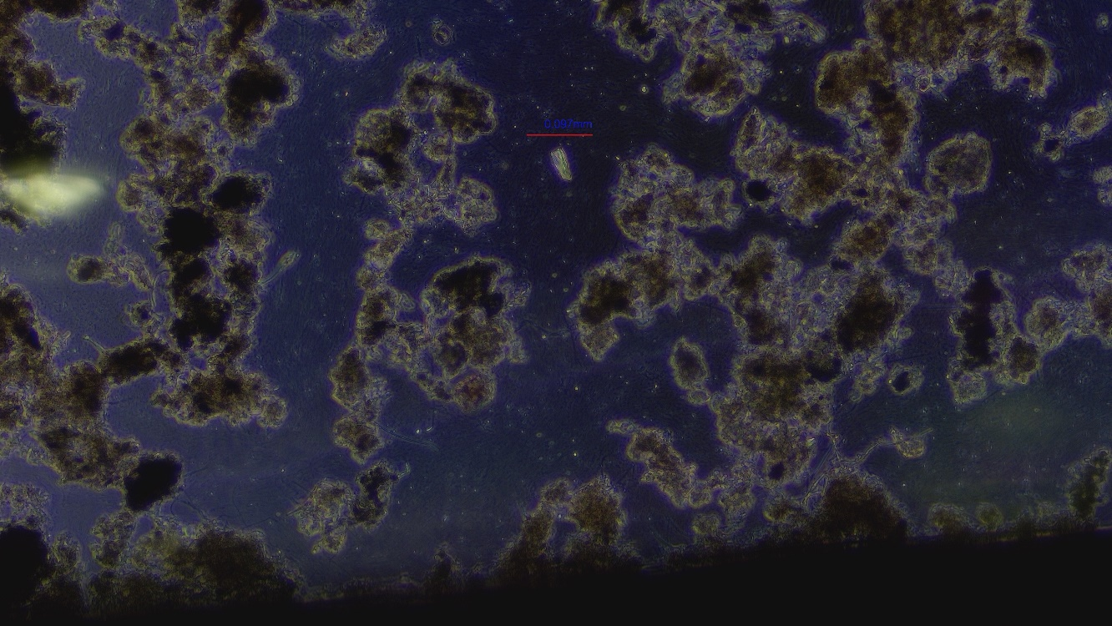
Figure 4.6 Shows only one possible crystal of struvite in dewatered biosolids at RED line.

The pH of the digester sludge initially was 7.1 and went up to 8.4 at the end of the serial dewatering process (Wu, Bishop, and Keener 2005). This is the result of the loss of carbon dioxide in the biosolids matrix (Wu, Bishop, and Keener 2005).
The biosolids dewatering process starts at the surge tank with a total % solids of ~2% and increases to ~24% total solids at the end of the dewatering process.

5.0 Benefits of this Research

The small- and full-scale pilots studies have, to date, demonstrated major benefits of feeding HCl by reduction of NH₃ and H₂S emissions throughout the area (Bennington, 2021). Reduction of odors during transport for land application of biosolids has also been confirmed (Bennington, 2021).
The application of HCl has been proven in previous tests to reduce NH₃ ppmv in biosolids and the application of FeCl3 was found to reduce H₂S ppmv below olfactory detection (Bennington, 2021). Both pilot studies reduced concentrations that were at or below the minimal human odor thresholds of 5-50 ppm NH₃ (Ryer‐Powder, 1991) and 0.10 ppb of H2S (Dincer and Muezzinoglu, 2007). The savings of hauling fees of more than $100,000 in 2023 helped to off-set both costs of chemical, and maintenance. Observations of semitrucks generating nuisance odors while in transit to application sites have been evaluated as trucks pass-by and no nuisance odors were observed. The intent of innovative odor mitigation is to provide our neighbors with excellent customer service by being accountable, demonstrating professional excellence and building trust throughout the community.
Employee safety is the first and foremost concern when implementing chemical applications. Employees were very sensitive to the handling and safety involved with chemical handling of HCl (32%). Division management, through transparency with employees, has provided multiple levels of safety. This includes identifying the hazard, exposure, and risk to each employee in the workplace. A unified approach has ensured that employee safety comes first. The graphs included within this research paper illustrate the possible hazards of both ammonia and hydrogen sulfide to employees that are observed when biosolids is not treated. Biosolids handling should always be performed in well-ventilated areas. Chemicals such as ferric chloride and hydrochloric acid should be handled according to all applicable state, federal, and local laws.

6.0 Methods Proposed for Ph.D. Dissertation Work

The objectives referenced in this section are introduced in Section 2.3 of this document. They are repeated here to connect the objectives with the proposed methods.

The project objectives are to:
- Describe the chemical mechanisms that result in the reductions of ammonia and hydrogen sulfide via chemical application of hydrochloric acid and ferric chloride to anaerobically digested biosolids during wastewater treatment dewatering process.
- Optimize the application of hydrochloric acid and ferric chloride to anaerobically digested biosolids via a bench scale study to minimize ammonia and hydrogen sulfide emissions.
- Optimize the application of hydrochloric acid and ferric chloride to anaerobically digested biosolids via a bench scale study to minimize struvite formation during the biosolids dewatering process.
- Apply the result from objectives 1-3 to assess the impact of hydrochloric acid and ferric chloride application to anaerobically digested biosolids in a full-scale dewatering process, with respect to the emission of ammonia and hydrogen sulfide gases, as well as the reduction of struvite formation.

For Objective 1. The method used will describe chemical mechanisms using chemical reactions for the known reactants in the system supported with accepted chemical modeling. For example,
ferric chloride reacts with hydrogen sulfide to form ferric sulfide and HCl:
2FeCl3+3H2S(aq)→ Fe2S3↓+ 6HCl (Othman et al., 2011)
Ammonia becomes ammonium with the application of HCl:
NH₃ + HCl = NH₄⁺ + Cl⁻

Specific tasks that will be completed are as follows:
- Describing the system of reactions using a software algorithm such as MINEQL+ Version 5.0 or equivalent.
- Determine the potential of fecal coliform reductions due to possible free chlorine availability.
- Evaluate risk of equipment failure due to ferric chloride application due to formation of precipitate.

For Objective 2. Bench-scale wet chemistry experiments will be conducted to apply different levels of FeCl₃ and HCl to biosolids to reduce the bench scale emissions of both NH₃ and H₂S emissions to acceptable levels. The following tasks will be performed:
- Determine minimum NH₃ and H₂S concentration levels achievable with chemical applications of both FeCl₃ and HCl.
- Predict the full-scale pilot concentration target values for NH₃ (0.043 ppmv to 60.3 ppmv) and H₂S concentrations to 1.0 ppmv.

For Objective 3. Bench-scale wet chemistry experiments will be conducted to apply different levels of FeCl₃ and HCl to biosolids to minimize struvite formation on coupons by optimizing sludge characteristics. The following tasks will be performed:
- Determine pH of biosolids matrix with FeCl₃ and HCl application
- Identification of the crystal formation of struvite in the laboratory using an Accu-Scope, EXC-350 Series microscope, to identify possible formation of early struvite crystal formation and the formation of precipitate on coupons.
- Analyze using GC/MS, Infrared Spectroscopy (FTIR) and Semi-quantitative elemental analysis by Energy Dispersive Spectroscopy (EDS) for chemical identification and quantification.
For Objective 4. Optimize full scale application of ferric chloride and hydrochloric acid.
The bench scale results will be examined to determine full scale application of FeCl₃ and HCL application at the City of Dayton Water Reclamation Facility located in Dayton Ohio. The full-scale application will be monitored and evaluated. Table 6.1 below lists the following sample locations, analysis, equipment and sample type that will be used during the project on the biosolids matrix to validate results. The following tasks will be performed:
- Optimize chemical applications using real time monitors to measure NH₃ and H₂S emissions to validate full-scale implementation.

Table 6.1 Sample sites, analysis, equipment used for measurements and sample type
Sample Location | Analysis of Measurements | Sample Equipment | Sample Type
Surge Tank | Ammonia | Acrulog Logger | Air/Continuous
Surge Tank | H2S | Acrulog Logger | Air/Continuous
Filtrate/Centrate/Biosolids | pH | Lab pH Meter | Liquid/Grab
Filtrate/Centrate/Biosolids | Alkalinity | Lab pH Meter | Liquid/Grab
Biosolids | H2S | Sensodyne Acrulog Logger | Air/Continuous
Biosolids | Ammonia | Acrulog Logger | Solid/Air/Composite
Biosolids | Struvite | Visual Identification | Solid/Composite

6.1 Tasks, and Timeline for Proposed Project
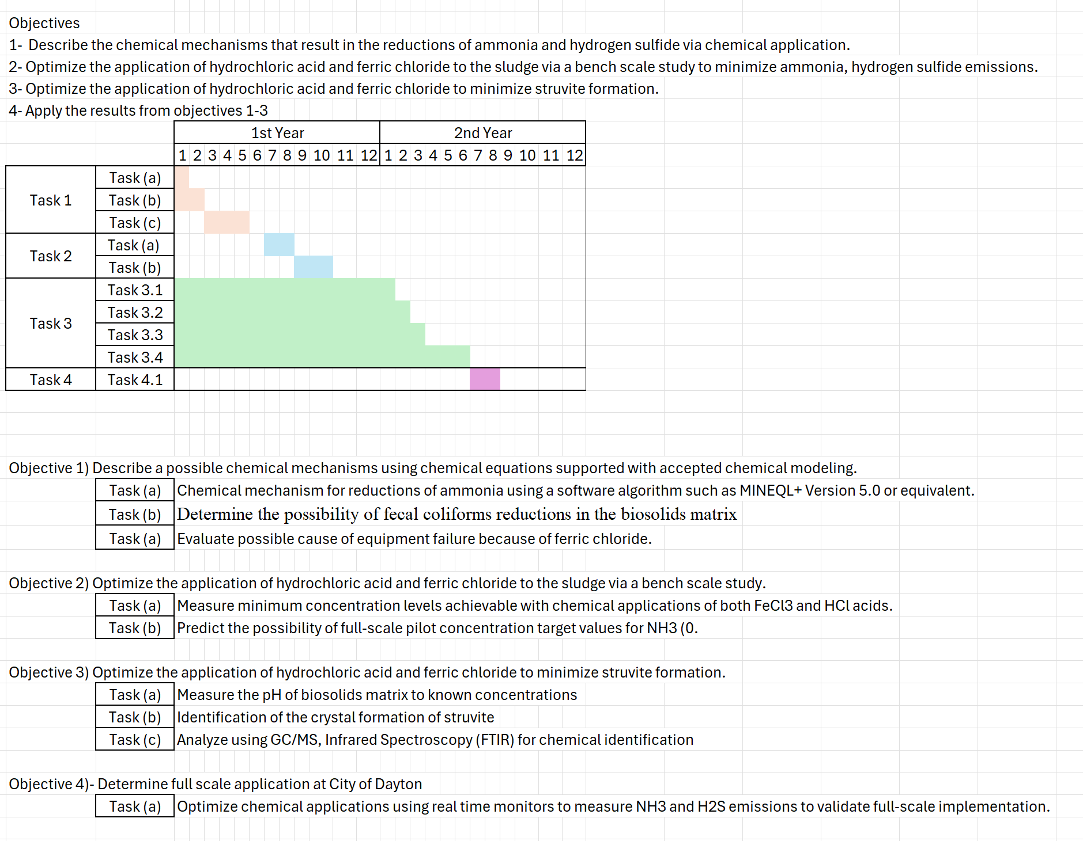

7.0 References

Ariyanto, E., Ang, H.M., Sen, T.K.: Effects of initial solution pH on solubility and morphology of struvite crystals, Department of chemical engineering, Curtin University of Technology, GPO Box U 1987 Perth WA, 6845
Baiming Ren, Yaqian Zhao, Nathalie Lyczko, and Ange Nzihou, 2018, Current Status and Outlook of Odor Removal Technologies in Wastewater Treatment Plant: Waste and Biomass Valorization (2019) 10:1443–1458 https://doi.org/10.1007/s12649-018-0384-9

Bennington, P., 2021. “The City of Dayton Water Reclamation Facility Biosolids Odor Control”, Capstone Project, Ohio University.
Brancher, Marlon, K. David Griffiths, Davide Franco, and Henrique de Melo Lisboa. 2017. “A Review of Odour Impact Criteria in Selected Countries around the World.” Chemosphere 168 (February):1531–70. https://doi.org/10.1016/j.chemosphere.2016.11.160.

DeLaune, P. B., P. A. Moore Jr., T. C. Daniel, and J. L. Lemunyon. 2004. “Effect of Chemical and Microbial Amendments on Ammonia Volatilization from Composting Poultry Litter.” Journal of Environmental Quality 33 (2): 728–34. https://doi.org/10.2134/jeq2004.7280.

Deng, Yang, and Casey M. Ezyske. 2011. “Sulfate Radical-Advanced Oxidation Process (SR-AOP) for Simultaneous Removal of Refractory Organic Contaminants and Ammonia in Landfill Leachate.” Water Research 45 (18): 6189–94. https://doi.org/10.1016/j.watres.2011.09.015.

Deng, Yang, and Renzun Zhao. 2015. “Advanced Oxidation Processes (AOPs) in Wastewater Treatment.” Current Pollution Reports 1 (3): 167–76. https://doi.org/10.1007/s40726-015-0015-z.

Deng, Y., Zhao, R., 2015.Advanced Oxidation Processes (AOP) in Wastewater Treatment, Water Pollution (S Sengupta, Section Editor), Curr Pollution Rep (2015) 1:167-176, Dot 10.1007/s40726-015-0015-z.

Dincer, Faruk, and Aysen Muezzinoglu. 2007. “Odor Determination at Wastewater Collection Systems: Olfactometry versus H2S Analyses.” CLEAN – Soil, Air, Water 35 (6): 565–70. https://doi.org/10.1002/clen.200700057.

Doyle, J.D. & Parsons, S.A.: Struvite Formation, Control and Recovery, 2002: Water Research, 36, 3925-3940.

Erdirencelebi, D., and M. Kucukhemek. 2018. “Control of Hydrogen Sulphide in Full-Scale Anaerobic Digesters Using Iron (III) Chloride: Performance, Origin and Effects.” Water Sa 44 (2): 176–83. https://journals.co.za/doi/abs/10.4314/wsa.v44i2.04.

Estrada, J.M., Krakman, N.J.R.B., Muñoz, R., Lebrero, R.: A comparative analysis of odour treatment technologies in wastewater treatment plants. Environ. Sci. Technol. 45, 1100–1106 (2011)

Fattah, K.P., Chowdhury, F.L.: Early detection of struvite formation in wastewater treatment plants: Journal of Environmental Engineering and Science: Volume 10 issue, April 2015, pp19-25.

Hsu, Yen-Chia, Jennifer Cross, Paul Dille, Michael Tasota, Beatrice Dias, Randy Sargent, Ting-Hao (Kenneth) Huang, and Illah Nourbakhsh. 2019. “Smell Pittsburgh: Community-Empowered Mobile Smell Reporting System.” In Proceedings of the 24th International Conference on Intelligent User Interfaces, 65–79. IUI ’19. New York, NY, USA: Association for Computing Machinery. https://doi.org/10.1145/3301275.3302293.

Keiser, David A., and Joseph S. Shapiro. 2019. “US Water Pollution Regulation over the Past Half Century: Burning Waters to Crystal Springs?” Journal of Economic Perspectives 33 (4): 51–75. https://doi.org/10.1257/jep.33.4.51.

Latos, M., Karageorgos, P., Kalogerakis, N., Lazaridis, M.: Dispersion of odorous gaseous compounds emitted from wastewater treatment plants. Water Air Soil Pollution. 215, 667–677 (2011)

Marti, N., A. Bouzas, A. Seco, and J. Ferrer. 2008. “Struvite Precipitation Assessment in Anaerobic Digestion Processes.” Chemical Engineering Journal 141 (1): 67–74. https://doi.org/10.1016/j.cej.2007.10.023.

Othman, Faridah, Shahram MortezaNia, Shahhin Ghafari, and Soenita Hashim. 2011. “Suppressing Dissolved Hydrogen Sulfide in Sewer Networks Using Chemical Methods.” Scientific Research and Essays, August. https://doi.org/10.5897/SRE10.897.

Pochwat, Kamil, Małgorzata Kida, Sabina Ziembowicz, and Piotr Koszelnik. 2019. “Odours in Sewerage—A Description of Emissions and of Technical Abatement Measures.” Environments 6 (8): 89. https://doi.org/10.3390/environments6080089.

Qingzhong, W., Bishop, P.L., Keener, T.C.: A Strategy for Controlling Deposition of Struvite in Municipal Wastewater Treatment Plants: Water Environment Research, March 2005.
Ren, Baiming, Yaqian Zhao, Nathalie Lyczko, and Ange Nzihou. 2019. “Current Status and Outlook of Odor Removal Technologies in Wastewater Treatment Plant.” Waste and Biomass Valorization 10 (6): 1443–58. https://doi.org/10.1007/s12649-018-0384-9.

Ryer‐Powder, Jill E. 1991. “Health Effects of Ammonia.” Plant/Operations Progress 10 (4): 228–32. https://doi.org/10.1002/prsb.720100411.

Stellacci, P., Liberti, L., Notarnicola, M., Haas, C.N.: Hygienic sustainability of site location of wastewater treatment plants: a case study. I. Estimating odour emission impact. Desalination 253, 51–56 (2010).
Stuetz, R.M., Frechen, F.B.: Odours in Wastewater Treatment. IWA Publishing, London (2001)
Tao, Fu-Ming. 1999. “Direct Formation of Solid Ammonium Chloride Particles from HCl and NH3 Vapors.” The Journal of Chemical Physics 110 (23): 11121–24. https://doi.org/10.1063/1.479054.

USEPA, EPA 832-F-00-067, September 2000, Biosolids and Residuals Management Fact Sheet, Odor Control in Biosolids Management
Webster Environmental Associates, Inc., Odor Control Engineering Study for the Synagro Biosolids Facility at the City of Dayton Wastewater Treatment Plant, November 2008 (revised December 18, 2008) 13121 Eastpoint park Blvd., Ste. E. Louisville, KY 40223

Webster Environmental Associates, Inc., Odor Control Master Plan for the City of Dayton Wastewater Treatment Plant, Revised December 2014, 13121 Eastpoint park Blvd., Ste. E. Louisville, KY 40223

